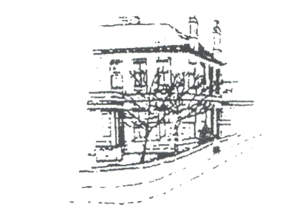
Dr David I Matthewson (GMC 3493953) Racecourse Road Medical Group
Dr Aileen Good (GMC 6128602) 3 Racecourse Road Dr Peter Paton (GMC 6026511) AYR KA7 2DF
Dr Carolyn Adams(GMC 4706568) Telephone No: 01292 Tel No: 01292 886622
Dr Vanessa Young (GMC 7036969)
Dr Lee-Ann Haddow (GMC 6077811) Website: www.rrmg.co.uk
Dr Katy McFadyen (GMC 7474545)

Complaints and the Use of Artificial Intelligence (AI)

We welcome feedback and complaints, and we want to understand your experience in your own words.

We are committed to handling complaints fairly, openly and compassionately, in line with the Scottish Public Services Ombudsman.

Some people choose to use Artificial Intelligence (AI) tools to help write complaints or emails. We understand that these tools can be helpful in organising thoughts or expressing concerns. However, AI-generated text can sometimes:

- include information that is inaccurate or not relevant;
- use legal language that isn’t needed, or applicable in Scotland;
- make complaints longer or more complex than necessary; or
- make it harder for us to clearly understand your personal experience.

This can occasionally delay our review or mean we need to contact you to clarify the details before we can respond fully.

The most helpful complaints are usually clear and concise, and explain:

- what happened;
- when it happened;
- how it affected you; and
- what you would like us to do to resolve the matter.

A short explanation in your own words is often more helpful than a long or highly formal letter.

If you choose to use AI tools, we recommend that you:

- check the wording carefully to ensure it reflects your own experience;
- remove any information that is inaccurate or not relevant; and
- take care when including sensitive personal information.

Please be aware that some AI tools may store or use information entered into them.

You may find this resource from Scottish Public Services Ombudsman helpful.

https://www.spso.org.uk/using-ai

